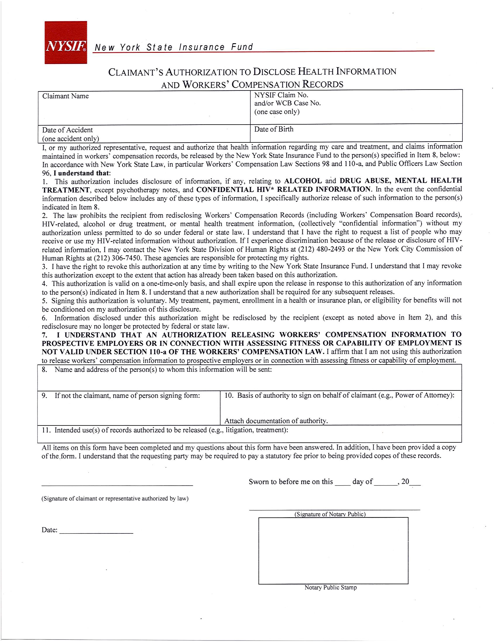
Batman

01/01/1979
Axiom Requisition Copy Service
2869 Jolly Road, Okemos, MI 48864 PH: (877) 886-5090 Fax: (517) 886-4116
Litigation

